#### Revision Guidance

“If you think you can, you can,

if you think you can’t, you can’t!”

Henry Ford



Prepared by the Staffordshire Learning Net

#### Top Ten Revision Tips

1. Short bursts of revision (30‑40 minutes) are most effective. Your concentration lapses after about an hour and you need to take a short break (5‑10 minutes).
2. Find a quiet place to revise ‑ your bedroom, school, the library ‑ and refuse to be interrupted or distracted.
3. Make sure you don't just revise the subjects and topics you like. Work on your weaker ones as well.
4. Make your own revision notes because you will remember what you have written down more easily. Stick key notes to cupboards or doors so you see them everyday.
5. Rewrite the key points of your revision notes; read them out loud to yourself. We remember more than twice as much of what we say aloud than of what we merely read.
6. Use different techniques. Make your own learning maps, use post‑it notes to write key words on, create flash cards. Record your notes on tape and listen to them back. Ask friends and family to test you. Use highlighter pens to mark important points.

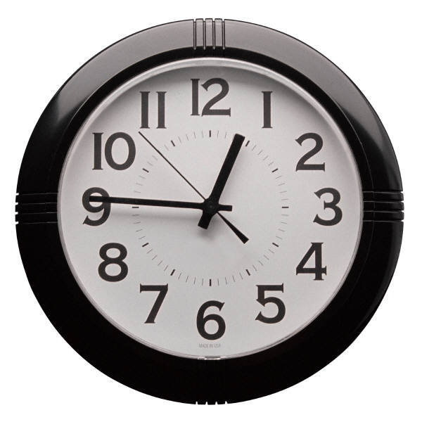

1. Practise on past exam papers or revision tests available on the web Initially do one section at a time and progress to doing an entire paper against the clock.
2. You will need help at some stage, ask parents, older brothers and sisters, teachers or friends. If there is a teacher with whom you get on well at school ask for their e‑mail address so you can clarify points you are unsure of whilst on study leave. Use websites specifically designed for revision.
3. **Don't get stressed out!** Eat properly and get lots of sleep!
4. **Believe in yourself and be positive.** If you think you can succeed you will; if you convince yourself that you will fail, that's what will probably happen.

### Effective revision

To be effective, revision must be:

* **Active** - always work with a pen and paper, look for key points, test yourself. Never just sit down and read for a set period. Focus on tasks, not time. If you just read notes you’ll only retain about 10% of the information.
* **Organised** - always ask yourself at the start of a study session "what do I want to have completed in this session?" Have a plan for what you want to cover this week and this month. Have an overview of the priority areas in each subject.

### Getting started on revision

**Where?**   
Find a fixed place to study (a particular desk/room at home, a spot in the library, etc.) that becomes firmly associated in your mind with productive work. All the equipment and materials you need should be within reach, and the room should be well lit and ventilated, but not too comfortable! Turn your room into a positive learning environment. Keep books and notes on the desk to a mini­mum and decorate your walls with colourful notes and key facts. Music is fine as long as it helps you to study and blocks out distracting noises. The very best sound to study to is thought to be that of Baroque composers or Mozart. Experiments show that brains are positively stimulated by such music.

**What?**  
Remember that it's all about being active and focused on tasks, not time! Know at the start of a session what you want to have completed by the end of the period. Make the tasks specific and realistic, not vague and large.

**How?**  
Always work with a pen and paper at the ready. Getting started is often the most difficult bit, so start by 'doing'. It usually helps to begin with a subject you like, move on to other less favoured areas, and then finish up with a favoured topic to maintain the interest.

**When?**  
Try to schedule your study for times when you are more mentally alert. Most people find their ability to focus deteriorates towards the end of the day. Getting revision done earlier in the day aids efficiency and also offers the reward of having time to relax after the work is done.

**Why?**  
Test your progress at the end of a study session. Ask yourself "what have I just learned?" Review the material covered in your revision session. Merely recognising material isn't enough - you must be able to reproduce it without the aid of the book or notes.

###### REVISION - Do’s and don’ts

DO

**1.** **Make a list of all the topics you need to revise:**  
Each subject that you are studying can be broken down into its constituent parts, with main sections, sub-topics and supporting details. A very useful start is to list out all the topics on the course according to this hierarchy and use this as a 'revision checklist' for the subject.  Tick topics off as you’ve learnt them.

  
**2. Create a realistic schedule.**

Block the waking part of each day into three portions. Allow yourself one portion a day off and allocate subjects and topics to the remaining two. Put the schedule on display so that your family can see when you are available. It will also reassure your parents that you are in control.

**3**. **Plan ahead by working backwards**  
By using revision checklists in your various subjects, you should know what quantity of material has to be covered over the coming weeks. Start from the final date and divide your revision up week by week, allowing some flexibility for unforeseen delays. Surprise yourself by being ready in time! Use the timetables and other sheets you have been given.

**4. Revise using your preferred learning style.**

Have you tried….. mindmaps, diagrams, colour, mnemonics, recording yourself and listening back to it, rewriting your favourite song using your revision notes for a topic as the words, walking round (Great for kinaesthetic learners – try read out the positive effects of X standing on the left hand side of the room and negative effects on the right hand side).

#### DON’T

**Just keep going!** The body and the mind need regular 'time-outs'. When you're tired, concentration is more difficult, you get distracted much easier and learning and memorisation is less effective. There comes a point in an evening study session when it is counter-productive to stay at the desk - nothing is going in and you are only tiring yourself further. Use breaks effectively, particularly after completing a task.

### Know how you learn best and then you can revise in ways that suit your style.

**Visual learners** prefer to:

* Draw pictures and diagrams
* Colour code their work
* Use different coloured paper, pens etc
* Use their own system of symbols etc
* Create images and scenes in their minds

j0238189

**Auditory learners** prefer to:

* Say their work aloud
* Give presentations to an imaginary audience
* Record notes on a tape recorder
* Use silly noises to remember things
* Hear the information in their mind
* Play instrumental music

j0349645

j0292058

**Kinaesthetic learners** prefer to:

* Do actions when learning key facts
* Walk about when learning
* Find it harder to sit at a desk
* Add emotions and textures to exaggerate information
* Try to experience what they are learning

**How should I revise?**

**Try one of these……**

**A:** MIND MAPS: Make mind‑maps or association maps rather than tak­ing linear notes. Mapping your notes by radiating key words out in a pattern of links from a central point will make best use of your memory. If you use colour and images on the maps, you'll be har­nessing the power of both sides of your brain ‑ creative and logical.

How to mind map:

1. Start with the theme in the middle of the page.
2. 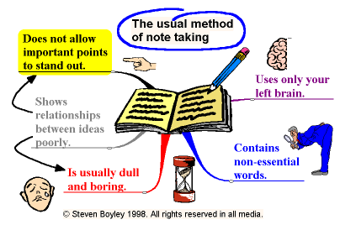Then develop your main idea.
3. Each branch must relate to the branch before it.
4. Use only key words and images.
5. Key words must be written along the branches.
6. Printing your key words makes them more memorable.



1. Use highlighters and coloured markers to colour code branches.
2. Make things stand out on the page so they stand out in your mind. (This doesn’t show up well on a black and whole photocopied booklet! You should use a different colour for each main branch and all its sub-branches)



1. Brainstorm ideas. Be creative.
2. Design images you can relate to which will help you remember key information.

Mindmaps can be mostly text…

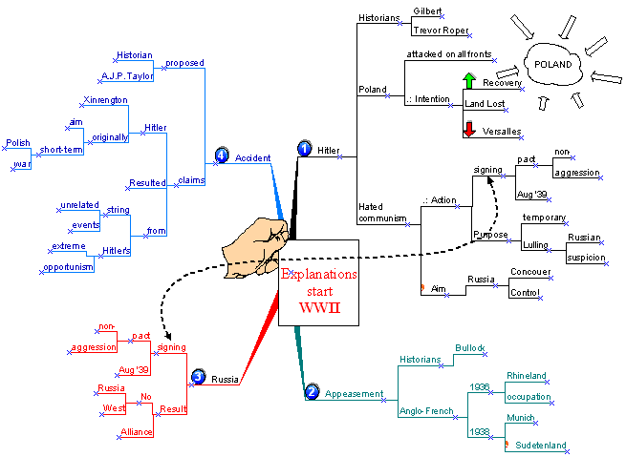

Or they can include more images (much easier to remember!) Look at this one summarising William Shakespeare’s life……. (again – much better in colour!)

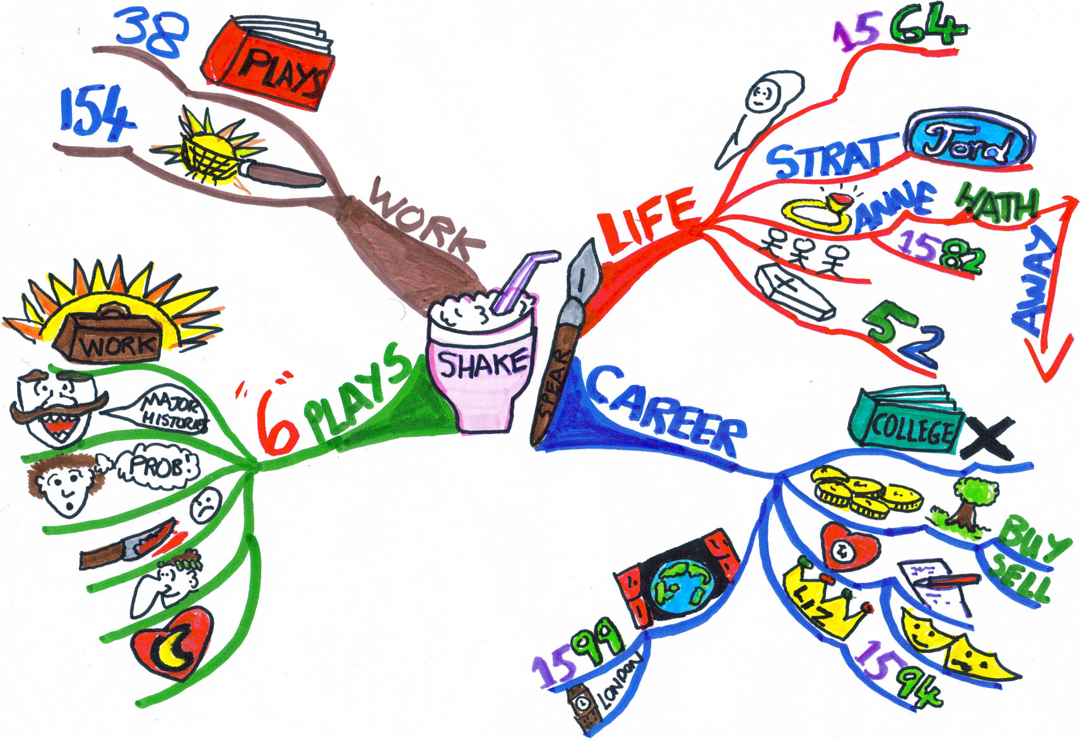

**B** Read intelligently. Spend five minutes flipping through a book or your notes looking at headings and summaries. Then attempt to mind map what you have spotted and what you can remember.



**C:** Use cards. Write questions on one side and answers on the other. Then get your family to test you. Merely creating the cards will help your recall. You can also use them to test yourself when faced with 'dead' time at bus stops or waiting for someone.

**D:** Physical learning:**Use the environment** Use a different room for each subject.

* Notice aspects of the environment such as the light or feel of the room - how do you feel in that place?
* Attach your notes to the furniture. Notice their location.
* Associate a different location with each subject. Associate furniture, windows, plants and ornaments with particular topics.

**Using the parts of your body**

* Parts of your body are especially helpful as triggers to memory, as your body will be there in the exam room! For example, each hand could represent an essay plan – each finger one major topic; each segment of each finger a principal reference you would use. The fingernails could represent counterarguments; the knuckles could be associated with relevant quotations.

**Use motor memory**

* Study on the move. If you exercise, associate each movement with something you wish to remember. To refresh the memory, go through the exercise in your mind.
* Writing, drawing and speaking also use motor memory: the fine-muscle sequence is recorded by the brain.

**E: Condense.** Fitting notes onto one side of paper makes them easier to stomach, so rewrite and cut down as you go.

**F: Highlight.** Target key areas using colours and symbols. Visuals help you remember the facts.

**G: Record.** Try putting important points, quotes and formulae on tape. If you hear them and read them, they're more likely to sink in.

**H: Talk.** Read your notes out loud, it's one way of getting them to register.

**I: Test.** See what you can remember without notes, but avoid testing yourself on subjects you know already. Why not ask someone else to test you?

**J: Time.** Do past exam papers against the clock, it's an excellent way of getting up to speed and of checking where there are gaps in your knowledge.

Reading Better and Faster

Most students, when faced with a textbook or chapter to study, will 'start at the beginning, read through at the same pace until the end, then stop and put the book away'. This passive approach is a most inefficient way to learn, as it can take longer and leave you bogged down in detail, with no overall grasp of the subject matter. By adopting a more *active* approach to reading, you can begin to read better and faster within a very short space of time. The **PQ2R** method has proved to be most successful in this regard. Try it for the remaining weeks of term and see the benefits.

**P = Preview**  
Begin your reading task with a quick skim (2-3 minutes) of the text, trying to get an overview of the chapter or text. Look for section headings, illustrative charts and diagrams, signposts or key words. Don't start highlighting text at this point.

**Q = Question**  
This is the key to active learning. Look for answers to the basic questions of "Who?", "What?", "Where?", "Why?" and "When?" Identify the main theme or learning point of the particular text.

**R = Read**  
Now read the chapter carefully, with these questions in mind. Your mind will be actively looking for answers as you read. Work with a pen and paper, make brief summary notes, look for 'topic sentences' that summarise the most important point in a paragraph or section and highlight them, if necessary. Vary your reading speed - move quickly over lighter, less important material and slow down when you come to a difficult section.

**R = Review**  
Always check your understanding of the material by reviewing and testing your recall before putting the text away. Look at the notes you have taken and check that they answer your initial questions. Summarise your findings from this study session.

**Making Your Notes Useful**

The purpose of making summary notes on a topic or section is to aid your overall understanding of material, to help you distinguish between what is really important information *(depth)* and what is merely supporting *detail*. Reference to the main syllabus topics will help the process of discernment within each subject.

In addition, good summary notes make retrieval of information quicker and easier.

* **Sort out your filing system**If you haven't already done so, get your subject folders and notes organised immediately. Invest in some ring binders, dividers, plastic pockets, etc. Have a separate folder for each subject (a permanent reference point) and then keep a 'current folder' for managing notes in progress.
* **Less is always more**When writing notes, remember they should contain a summary, not an extensive repetition of what is in the textbook. Don't crowd the page. Stick to main headings and sub-headings. Use abbreviations where appropriate. Try to reduce what you need to know on the topic down to one A4 sheet. Once you have an overview, it is easier to fill out the detail.
* 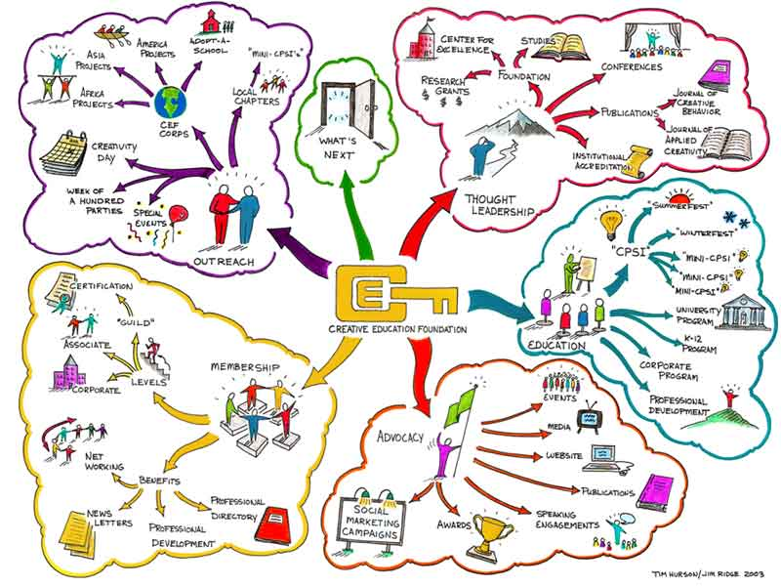**Make your notes visual**  
  Ensure your notes have a memorable appearance so that you can recall them easily. Use illustrations, diagrams, graphs, colours, and boxes ('a picture is worth a thousand words'). Arrange the material in a logical hierarchy (title, sub-point, explanation, example). Ideally, you should be able to close your eyes in an exam and visualise a particular page of notes.
* **Beware of transcribing and highlighting!**  
  Merely re-writing the text from the book into your notes does not ensure retention. Try to put things in your own words and devise your own examples - this will make the material more meaningful. Only use the highlighter pen AFTER you have previewed and questioned a text, thus ensuring you identify the most important material and you avoid the creation of a fluorescent textbook!
* **'Save' your notes carefully**  
  Practice following the logic of your computer files, when storing information. Think - "Where does this material best fit (subject, section, topic, sub-topic, etc.)?" In this way, you will ensure that it is efficiently processed and easily retrieved both physically (during revision) and mentally (when you need it in an exam).

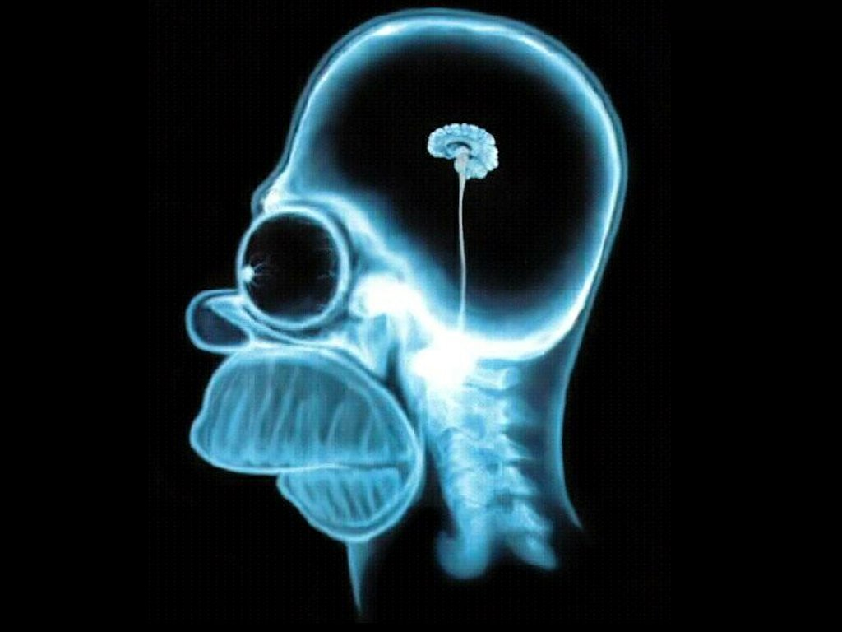Improving Memory

We often blame our memory for poor academic performance ("I'm no good at remembering names / dates / rules / verbs / characteristics") when really we should be addressing our faulty input and storage system. There is a big difference between short-term and long-term memory. If you study a topic one night and can recall most of it the next morning, don't be fooled into thinking that you will be able to remember it accurately in two months time.

If the goal is to improve your long-term memory, then the key to success is based on the efficiency of input (the 'mental filing system' we employ). Reducing the burden on the limited short-term memory, and channelling information into long-term storage, is based on the creation of patterns and the avoidance of randomness.

* **'Chunking':** as the average person can only hold seven 'items' in short-term memory, grouping items together into 'chunks' can increase capacity. This is generally used for remembering numbers (think of how you remember phone numbers by grouping the seven digits into 2 or 3 chunks) but can be applied to other listings in various subjects.
* **Repetition:** Studies indicate that 66% of material is forgotten within seven days if it is not reviewed or recited again by the student, and 88% is gone after six weeks. Don't make life harder for yourself - build in a brief daily and weekly review of material covered. It will save you having to re-learn material from scratch!
* **Application and association:** The best way to channel material to long-term memory is to organise it into meaningful associations. Link it to existing information and topics and create vivid personal examples which act as 'mental hooks' or 'cues' for recalling material in the future. Thus, new items are put in context. If you learn a new formula / verb / rule, try to put it into practice immediately with a relevant example.
* **Use of mnemonics:** these are various word games which can act as memory aids and which allow personalisation and creativity. Think of stalag*tites* (come down from the ceiling) and stalag*mites* (go up from the ground); the colours of the rainbow - **Roy G. Biv** ('**R**ichard **O**f **Y**ork **G**ave **B**attle **I**n **V**ain' to remember red, orange, yellow, green, blue, indigo, violet); the seven characteristics of living organisms - **Mr. Grief** (**M**ovement, **R**eproduction, **G**rowth, **R**espiration, **I**rritability, **E**xcretion, **F**eeding). You can devise many more of these to aid your personalised recall of items in your subjects.

Looking over a topic every now and then will help to keep it in the memory, taking away the need to cram before exams.

Make a summary of the work and look over it ten minutes later, the next day, the next week and then the next month for a few minutes each time. This reinforces the knowledge learned.

Understanding increases as time spent studying passes. However, the ability to recall things being memorised becomes progressively less efficient as time passes in a study session.

20 minutes is needed for the mind to get into the rhythm of and flow of the material. Any more than 40 minutes spent memorising means that memory declines to a point where it is no longer valuable.

The answer in revision therefore is to do 30 minutes with a 5-minute stretch break and then review the topic.

After a one hour memorising session:

10 minutes later revise the topic for 10 minutes

1 day later revise the topic for 5 minutes

1 week later revise the topic for 2-5 minutes

1 month later revise the topic for 2-5 minutes

Before exams revise the topic as required.

**Each time knowledge is reinforced; it enters deeper into the long-term memory and becomes more stable.**

Practising Output

To prepare for an exam, ***you must practice doing what the exam requires you to do; giving out information, not taking it in!*** This applies to regular class tests as well as the final exams.   
  
Prior to your exams, you will probably have had the benefit of many class tests and some modular exams where the conditions are simulated for your benefit – you can learn a lot by reflecting honestly on your performance in these tests. You also have the benefit of a wealth of freely available information about the exams. Past exam papers, marking schemes, study guides and examiners reports are all there to be used.

* **Make use of past papers**  
  These should be your constant companion in all revision tasks. For each topic you revise, consult the past questions on this subject and then attempt answers to them. Check your answers, fill in the 'knowledge gaps' where necessary, and file away the correct 'model answer' in your notes for future reference. You will also start to notice any trends in the questions asked.
* **Follow the marks**  
  Marking schemes are an invaluable aid to exam preparation. You can see how the marks are allocated for each question on the paper and what quantity or style of answer is required in each case. This knowledge will greatly inform your revision work and helps to remove the mystique of the exam.

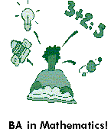**Try a dress rehearsal**  
Each exam paper contains its own particular structure and challenge, with varying emphasis on answering style and depth. While much of your ongoing revision will be based on individual topics and questions, it is a very useful exercise to tackle an exam paper in its totality. It forces you to consider your strategy – the questions you will want to attempt or avoid, the issues of timing, the number of points you will need to make in each part of a question. Having performed this exercise a couple of times, your confidence levels rise as you fix on your strategy for the exam and realise that there can't be any major surprises for you.

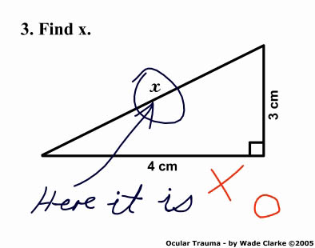The Examiner's View  
You can largely determine the end result by simply heeding the voice of experience. The job of examiners is to give you marks, not to take them away, but they are powerless to help you if you fall into the most common traps. These are the **biggest pitfalls** they have identified:

* **Not reading the paper correctly**  
  Examiners say that this is one of the most regular and fatal errors. They call it the *'triggered answer'*. You have your pre-prepared answer ready but you don't look at the exact terms of the question and therefore supply the wrong information in your answer.
* **Not finishing the paper**  
  Mismanaging your time within the exam can easily cost you a full grade. The biggest exam 'crime' is to leave suitable questions unattempted. ***Remember: it is much easier to get the first 20% of the marks for any question than the last 5%.*** Therefore, if you find yourself stuck for time as you struggle through your third answer out of five, do not spend your remaining time extending and perfecting that answer. Instead, move on to questions four and five, even if your attempt is sketched or in point form. If you have answered only three questions instead of five, the highest mark you can get is 60%.
* **Ignoring the marking scheme**  
  You must take the marking scheme into account when you allocate time to each question or part of a question. If the marks allotted to a question clearly indicate that a few paragraphs are sufficient, do not write an essay on the subject. Avoid the temptation of writing everything you know about a topic – just give the appropriate amount of information.
* **Repetition**  
  Make the point once. There are no extra marks for restating facts, even if you phrase them differently. Examiners say repetition is a very common mistake. It is also a time-waster and an irritant.
* **Missing a question**  
  Always take time to familiarise yourself with the whole paper before you start answering it.
* **Irrelevant quotations**  
  In literary subjects, don't use irrelevant quotations just for the sake of it, as it only irritates the examiner. The must be relevant and integrated.
* **Rough work**  
  Include your rough work with your exam script – you might get some credit for formulae or calculations. Cross a plan or rough work through with a single line.

MCj04300470000[1]Performing on the Day

* **Get a good night's sleep**  
  While the temptation is to stay up half the night 'cramming' in more facts and figures, the evidence suggests this approach is counter-productive. In the context of a one or two-year course, an extra night's studying can make very little difference to your knowledge. However, having a mind that is refreshed, alert, and ready to respond to circumstances will obviously be of far greater benefit.
* **Arrive in plenty of time:** To perform well on the day, you need to be relaxed and to feel in control of the situation. This is difficult to achieve if you have missed breakfast and are stuck on a bus in traffic or standing on a train for 45 minutes as the exam time approaches. You will need about 15 minutes 'quiet time' to mentally rehearse your exam and run through your 'game plan' for the final time.
* **Have your equipment ready**  
  Each exam has its own requirements. Apart from properly functioning pens, pencils, rulers, etc, you may need a calculator for the Maths or Science exam. Drawing pencils may be required for diagrams in some subjects. A lot of nervous energy can be expended on last-minute hassle if these items aren't checked in advance.
* **Think positive**  
  On the day of the exam, remind yourself of the good things (the material you know well, the revision you have completed, all the past exam questions done, the good grades achieved) rather than dwelling on areas of weakness. Having that self-belief will give you the confidence to trust your judgement within the exam hall and 'hit the target'.
* **Maintain your focus**  
  There can be a lot of tension, drama, and hysteria in the air on the days of an exam. You want to keep the balance between maintaining your focus and interacting normally with your friends and classmates. Try finding a quiet spot *far from the madding crowd* to 'warm-up' before each exam and 'warm-down' afterwards. Surround yourself with people who are likely to add to the calm rather than add to the clamour.
* **Beware of post-exam analysis**  
  The more you participate in the exam post-mortem, the more confused and disheartened you are likely to become. You can't change what has happened, you can only focus on the present and this will need your full attention.

Top Tips on Exam Strategy

Success in exams involves two ingredients - having a thorough knowledge of the subject matter AND making the most of your knowledge in the exam through effective answering technique. Two students with identical knowledge and attainment levels can sit the same exam and their final grades can differ by as much as 25%. The difference is down to having an effective strategy and exam technique.

*Here are four golden rules to apply to your papers:*

1. **Allow time to read the paper carefully**  
   The importance of reading the paper carefully and choosing your questions wisely cannot be emphasised enough at this stage. The natural inclination is always to start writing immediately and launch into a favoured topic. Resist the urge. Take your time. Be smart and size-up the paper before answering.
2. **Stick to your game plan**  
   An overall strategy should have emerged from your revision and exam preparation in each subject. This covers the areas you will tackle, the topics you will avoid if they appear on the paper, the sequence in which you will tackle the various sections, the style of answering you will employ in each subject, the amount of time you will allocate to answering each section. In some cases, this plan will work like a dream but there will always be surprises to deal with in some papers. Don't get flustered. Stick to your game plan, trust your judgement, and move on.
3. **Sweep up any mistakes**  
   In the pressure of the exam hall, it is easy to make elementary errors. These will sometimes have the potential to lose you a lot of valuable marks. Misreading the instruction on a question can render an entire answer invalid. You might have known the correct answer, but you didn't put it down. A simple miscalculation can lose you valuable time as you try to figure out the balancing item. Be disciplined with your time. Always leave a few minutes at the end to tidy-up errors. Simply changing a definition / formula / calculation at this stage could be the difference between a good and an average grade.
4. **Attempt all questions**  
   It is amazing how many exam scripts are handed up unfinished. Every year, capable students who just didn’t get time to finish the paper lose easy marks. Don't fall into this trap. Work on the basis that you will get an answer written for the required number of questions. Remember that it is much easier to get the first 20% of the marks for any question than the final 5%. You can always polish an answer further but, if there is no attempt made at part of a question, the examiner can't give you any marks. BUT if the instructions on the front of the paper tell you to answer a certain number of questions – stick to this - don’t answer too many!

Answering Exam Questions

1. Scan **all** the questions.
2. Mark all the questions you could answer.
3. Read these questions carefully.
4. Choose the correct number of questions in each section.
5. Decide on an order: ***best answers first***.
6. Divide up your time, allowing more time for the questions with the most marks.
7. 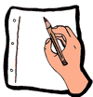Underline the key words in the question.
8. Plan your answer.
9. Stick to the point of the question.
10. Write your answer.
11. Use the plan at every stage – e.g. every paragraph.
12. Check your answer against the plan. Look out for mistakes.
13. If you have time, re-read the questions and your answers and make any necessary corrections.

Dealing With Distractions

* *"I just start daydreaming"*Become an active learner. Always work with a pen and paper. Focus on a specific task, not a specified time for your study.
* *"I can't focus because I'm anxious about the exams"*Try to limit yourself to your immediate concerns, the things you have some control over (preparation for the upcoming revision test) rather than the things you cannot determine (like what questions the examiners will choose for this year's English Lit paper.)
* *"I often fall asleep when I'm supposed to be studying"*Try to get to bed on time over the coming weeks. A tired brain is very unproductive. Get some genuine rest at the weekend. Be sure to get regular exercise, even just a walk around the block at night to clear your head.
* *"I'm constantly interrupted by other people"*  
  Study in the location most likely to offer peace and quiet. Ask for consideration from family members over the final run up to exams. Never have a TV, phone, computer game, or music system within arm's reach while you are trying to work. Make a rule of not taking phone calls within certain defined periods.
* *"I keep thinking of other things while I'm studying"*Divide the study session into smaller, short-range goals which demand your full attention e.g. vocabulary or poetry test. Keep a 'reminder pad' beside you, a little notebook to jot down something that strikes you (someone to call, a job to do, etc.) and deal with it after the study period. Having made a note of it, you can more easily re-focus on your work.

###### OTHER BITS!

**Healthy Body = Healthy Mind**

**Food for thought**: Eating a variety of healthy foods doesn't just give your body a boost, it also benefits your brain cells. Skipping meals may well give you extra cramming time, but it can also leave you hungry and unable to concentrate, So, eat regularly and sensibly. Think wholemeal sandwiches and fruit, rather than cakes and biscuits!

**Brain Fuel**

* MCj03595710000[1]Bread, pasta, cereals and potatoes are filling and packed with starchy carbohydrates, which release energy slowly.
* Fruit and vegetables give you essential vitamins and minerals.
* Drink plenty of fluids. Dehydrated brains don't think clearly and water is healthier than sweet, fizzy drinks.
* Meat, fish, pulses, milk and dairy foods are good sources of protein. Moderate amounts are essential for a healthy diet.
* Make sure you eat breakfast on the day of an exam.
* [](http://images.google.co.uk/imgres?imgurl=http://www.acclaimimages.com/_gallery/_SM/0093-0509-2113-2628_SM.jpg&imgrefurl=http://www.acclaimimages.com/_gallery/_pages/0093-0509-2113-2628.html&h=300&w=242&sz=68&hl=en&sig2=bV3W3PAAmyHN5H57uPKdQA&start=6&tbnid=lJSrPSlM167CSM:&tbnh=116&tbnw=94&ei=VNDDRZSiHMLqwQGg6LiJDg&prev=/images?q=cartoon+walking&svnum=10&hl=en)If you’re not getting enough iron then you’ll damage your ability to concentrate for long periods of time and your energy levels will begin to drop. Try eating more red meat, eggs and leafy green vegetables like spinach.

**Exercise:** Staying in your room can seem like the best option when revision time is short. But a bit of the great outdoors can blow the cobwebs away and help you relax. If you can't get out, at least get up and out of your chair for a stretch and a wander. Better still, go for a swim or put those footie boots on and give your mind and body a workout.



Stress Management

#### Get organised

Have a realistic daily schedule including revision, sleep, eating, relationships and recreation.

##### Be positive

Talk positively to yourself! Don’t pay attention to that internal voice saying you can’t do it; tell yourself you can do it and you will do it.

##### Talk

Talking and meeting with friends and occasionally sharing deep feelings and thoughts can be helpful in reducing stress.

###### Stay calm

Make sure you are in a calm, positive mood before you start studying.

###### Be healthy

Watch your eating habits. Make sure you eat sensibly and have a balanced diet. Avoid too much chocolate, cola, caffeine and foods with lots of additives.

Drink lots of water.

###### Sleep

Don’t become overtired by forcing yourself to work late. Your brain needs time to sort out the information it has come across during the day. Your ideal sleep time is about 8 hours a night.

###### Make a list

Make a list of the things that are worrying you and the possible things that could happen – then your brain will stop bringing them forward all the time.

**Time**

Recognise that you can only do so much in a given time. **Try to pace, not race.**

###### Exercise

Physical activity provides relief from stress. The brain uses 20% of oxygen in the blood so you need to think about your posture and exercise to make sure your body gets enough. 30 minutes of sport or a short walk will do the trick.

###### Learn to relax

Take mini breaks throughout the day. Work on relaxation techniques, such as taking slow deep breaths.